**Triosigno BTP Scenario 1**: [https://youtu.be/iulZJXAkNZ0[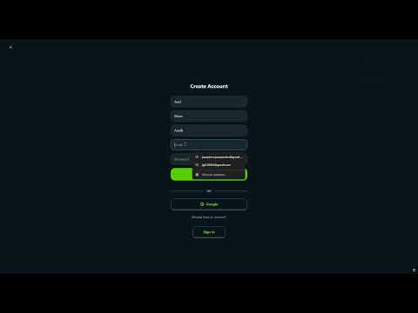](https://www.youtube.com/embed/iulZJXAkNZ0?feature=oembed)](https://youtu.be/iulZJXAkNZ0#)

**Triosigno BTP Scenario 2**: [https://youtu.be/iR8UePpLueY[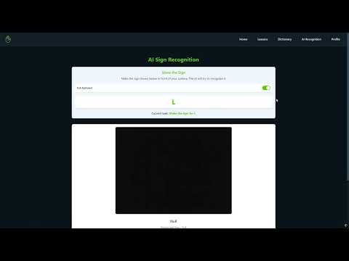](https://www.youtube.com/embed/iR8UePpLueY?feature=oembed)](https://youtu.be/iR8UePpLueY#)

**Triosigno BTP Scenario 3**: [https://youtu.be/wqorAau1FcI[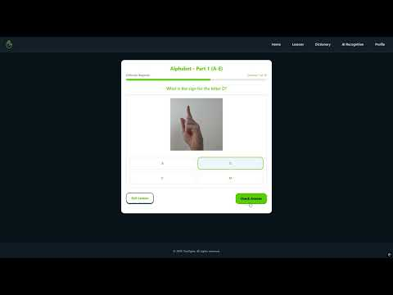](https://www.youtube.com/embed/wqorAau1FcI?feature=oembed)](https://youtu.be/wqorAau1FcI#)

**Triosigno BTP Scenario 4**: <https://youtu.be/ff-c-7T_T7w>[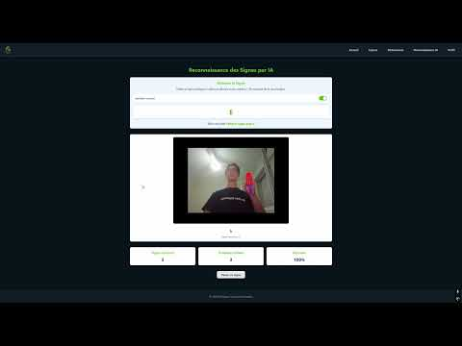](https://www.youtube.com/embed/ff-c-7T_T7w?feature=oembed)

**Triosigno BTP Scenario 7**: <https://youtube.com/shorts/cuFYLEh3KuI>[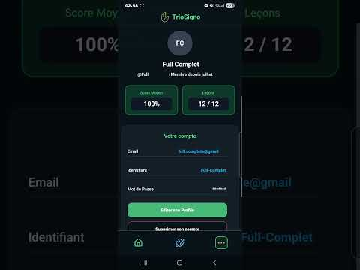](https://www.youtube.com/embed/cuFYLEh3KuI?feature=oembed)